1. **Diode Rectifier - Buck Converter**

This topology consists of two main parts which are the rectifier part and the converter part. In the rectifier part, a diode rectifier is used to convert AC signal to DC signal with ripple. The ripple voltage can be decreased by using a parallel capacitor at the output.However, when the ripple gets higher, larger capacitors are needed. Three-phase full-bridge rectifier is a good option for rectifier part since it gives the minimum voltage ripple among the diode rectifiers. Then, the output of this rectifier is connected to a buck converter. Buck converter is a pull DC-DC converter that uses a switch to regulate the output voltage. When the duty cycle of the switch decreases, the output voltage drops. In our simulation, we used IGBT as switch.

First advantage of this topology is, it is relatively easier than the thyristor topologies and the alternistor triac circuits so it is easier to implement the circuit .Therefore, it is more suitable for obtaining more bonuses. Secondly, diodes are much cheaper than thyristors and using DC Motor at the output eliminates the necessity of using inductor and capacitor at the output of buck converter. Finally, it is easier to arrange the gate signal of the switch at buck converter than arranging six pulses that is going to the thristors.

One disadvantage of this topology is, it is not suitable for 4 quadrant operation like thyristor topology.

**ANALYTICAL CALCULATIONS**

**THERMAL CALCULATIONS**

In this part of the report, the losses and the related thermal calculations are shown. In semiconductor materials, the main losses are switching losses and conduction losses. The equations related to these losses are shown in Equation 3,4 and 5.

$P_{loss}$ = $P_{conduction}$ + $P_{switching}$

*Equation 3*

$P_{conduction}$ = $V_{f}×I_{on}×(Duty Cycle)$

*Equation 4*

$$P_{switching}=(E_{on} + E_{off})×f$$

*Equation 5*

For the bridge rectifier, the switching loss of the diodes are not indicated in the datasheet. Thus, only the conduction losses are considered. According to datasheet, $V_{f}$ = 1.1V for each diode and the mean value of current on each diode is 11A . Since we are using 2 single-phase bridge rectifier blocks, 4 diodes are used in one component,whereas only 2 is used in the other one.

$$P_{loss-rectifier}=(1.1V)×(11A)×4=48.4W$$

For the free-wheeling diode, since the switching losses are not given in the datasheet, the total switching loss is calculated by the linearized model. Since only the reverse recovery time is given in the datasheet (it is more dominant than the forward recovery time), forward recovery time is neglected.

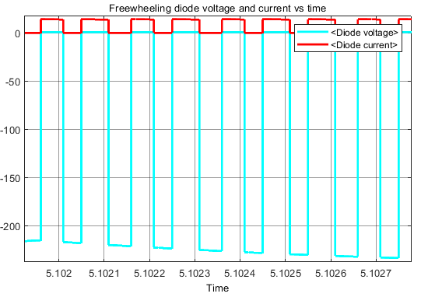

*Figure 4.1: Current and Voltage Characteristics of Freewheeling Diode*

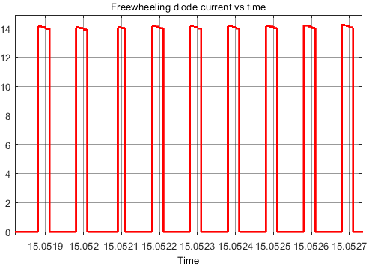

*Figure 4.2: Current Characteristic of Freewheeling Diode*

As seen from Figure 4.1 and 4.2 , $I_{on}$ = 14 A and $V_{on}= 225 V.$ Reverse recovery time is found 40 ns from the datasheet. The duty cycle of the diode is 0.2 when the max duty cycle is applied to the IGBT(which is 0.8). The calculations are displayed below.

$$P_{loss-diode,switching}≃0.5× I_{on} × V_{on}×t_{rr}=3.15mW$$

*Equation 6*

$P_{loss-diode,conduction}= 2.27V × 14A × 0.2 = 6.36W$

$$P_{loss-diode}≃6.36W$$

Losses in IGBT are calculated below.

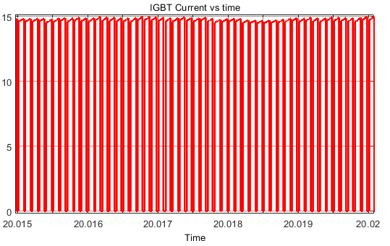

*Figure 4.3: Current Characteristic of Freewheeling Diode*

$$P_{loss-IGBT,switching}=(0.3mJ+0.4mJ)× (10kHz)=7W$$

$$P_{loss-IGBT,conduction}= (2.28V) × (15 A) × 0.8 =27.36W$$

$P_{loss-IGBT}=34.36W$

To find the thermal resistance of the heatsink for each element equation 7 and equation 8 is used. The ambient temperature is 40 $C^{o}$ and maximum junction temperature is ${125C}^{o}$ for the components.

$$R_{th-needed}= R_{th-needed}+R_{th-heatsink}$$

*Equation 7*

$$R_{th-needed}=(T_{max}-T_{ambient})÷(P)$$

*Equation 8*

For rectifier;

$$R_{th-needed,rectifier}=(85 C^{o})÷(48.4)=1.76 C/W$$

Since the thermal resistance of the component is 2 C/W, we will cool this component with a fan.

For free-wheeling diode;

$$R_{th-needed,diode}=(85 C^{o})÷(6.36)=13.36 C/W$$

$$R_{th-heatsink,diode}= 13.36 C/W -0.7 C/W = 12.66 C/W$$

This diode has a TO-220 package which is suitable for the heatsink provided by the department but this component’s datasheet is not provided. This heatsink will be tried first. If it doesn't satisfy the thermal needs of the component, another heatsink will be used.

For IGBT;

$$R_{th-needed,IGBT}=(85 C^{o})÷(34.36)=2.47 C/W$$

$$R_{th-heatsink,IGBT}= 2.47 C/W -0.65 C/W = 1.82 C/W$$

530802B05100G heat sink will be used for cooling IGBT. It is suitable for TO-247 package and it gives the necessary thermal resistance value with appropriate cooling.